**PROBLEM STATEMENT :**

7) Hosting a website on EC2.

***Steps to host a website on EC2->***

1. Sign up for an AWS account, search for ‘EC2’ then click on it.

2. Click on ‘Launch instance’.

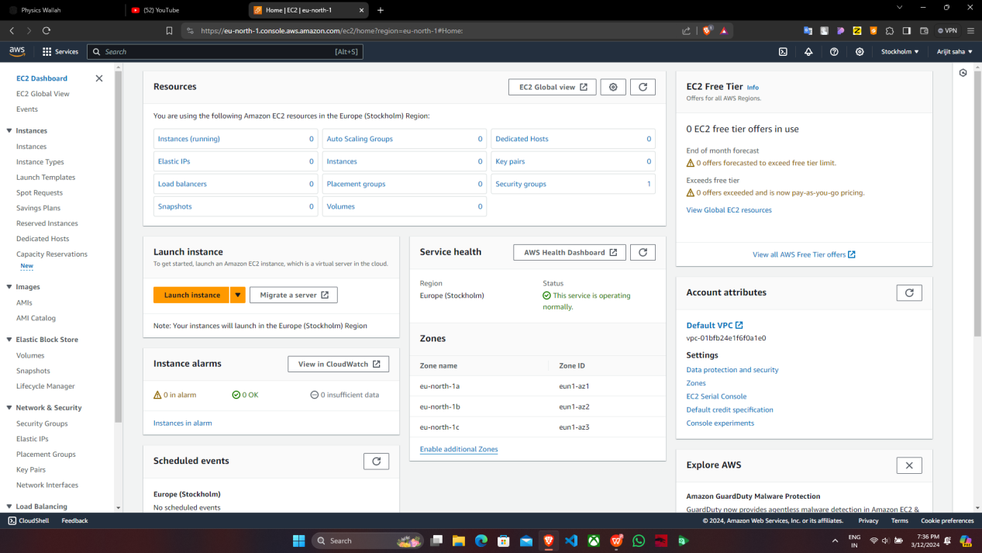

1. Fill up the required details->’Name’, in ‘Application and OS Images’ select ‘ubuntu’.

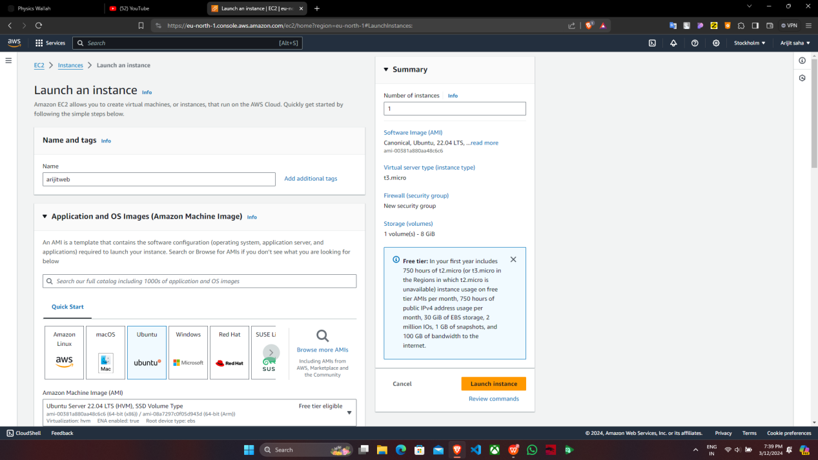

In ‘Key pair(login)’, click on ‘Create new key pair’, give ‘key pair name’ and click

on ‘Create key pair’.

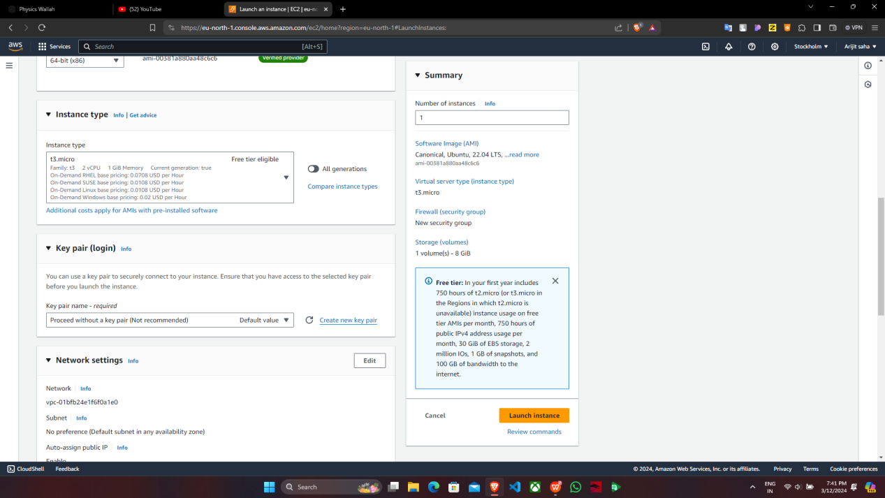

Under ‘Network settings’, tick off all the three checkboxes then click on ‘Launch

instance’.

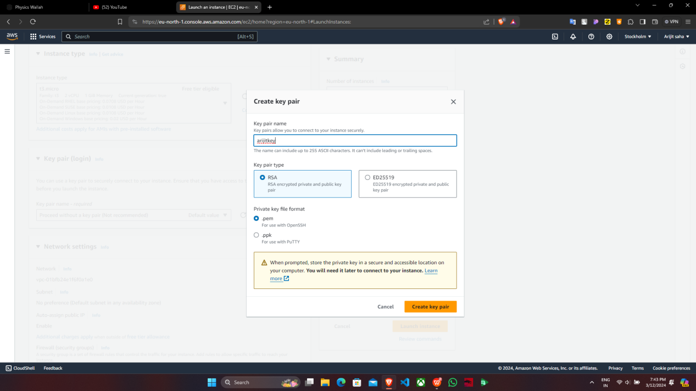

4. ‘arijitweb’ instance is created successfully and then click on

‘Instances’.

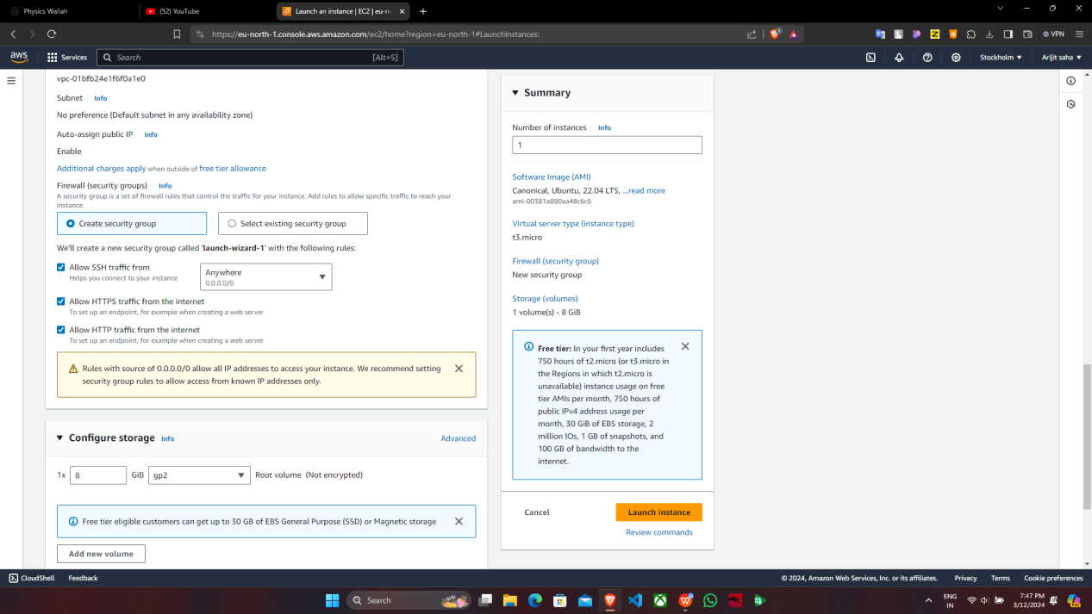

5.Now click on ‘Instance ID’.

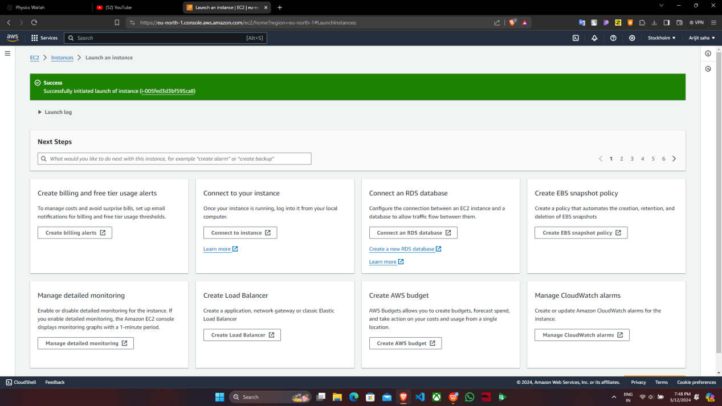

6.Click on ‘Public IPV4 address’ & copy it then open ‘Bitvise SSH Client’.

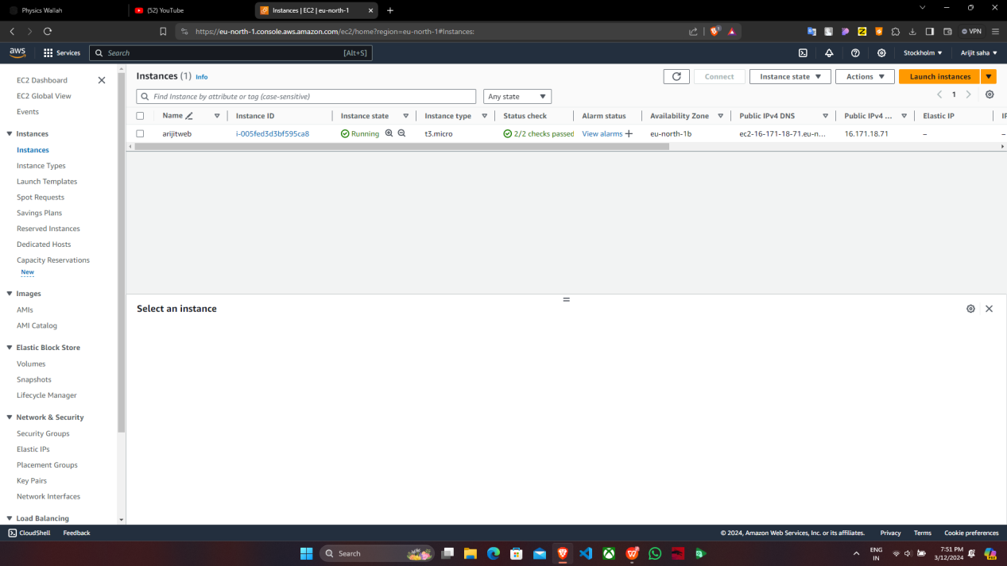

1. In Bitvise SSH Client, paste the ‘Public IPV4 address’click on ‘Client key Manager’.

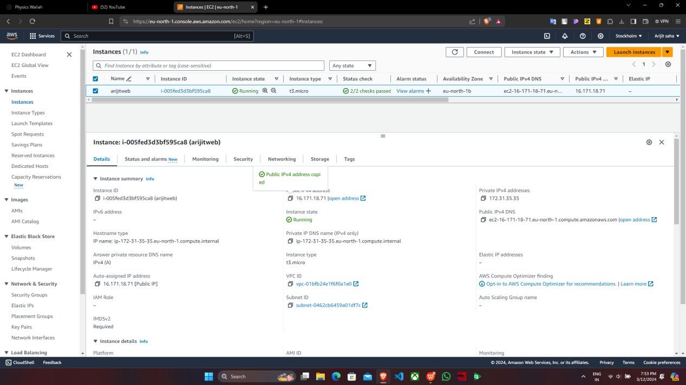

8. Under ‘Client key manager’, if there is any existing key then remove it and click on ‘Import’ , select the created key ‘arijitkey.pem’ then again click on ‘Import’ and then the key is successfully imported.

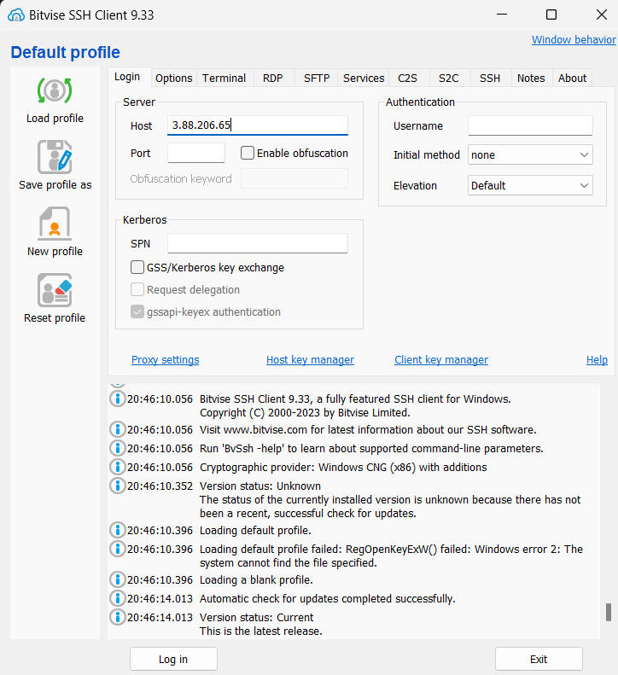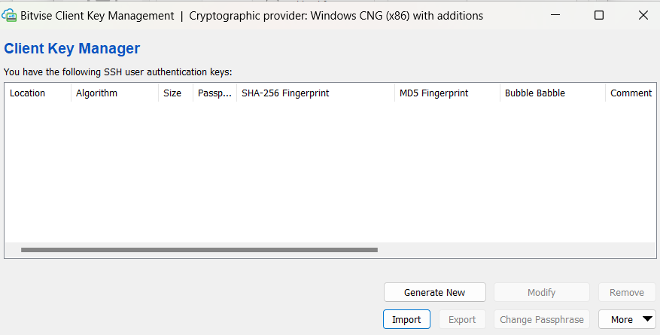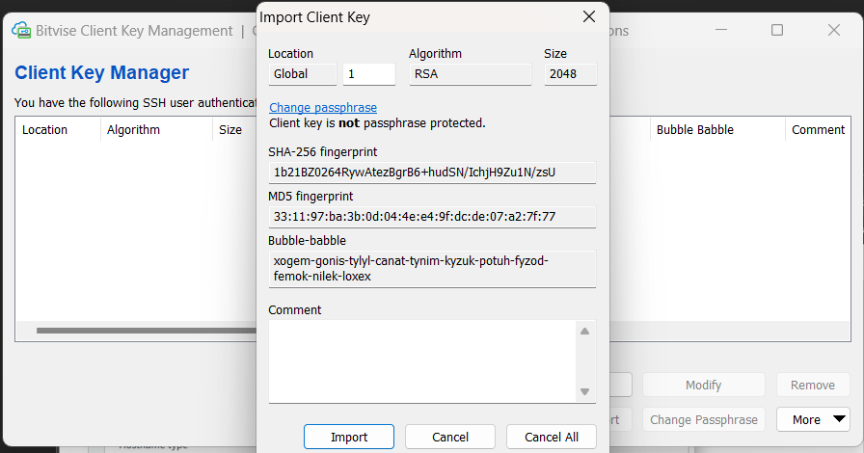

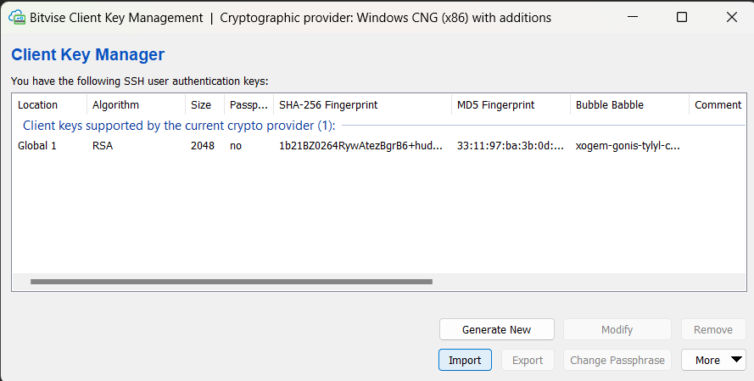

9. In ‘Bitvise SSH Client’, under ‘Default profile’ give the ‘Username’ as

‘ubuntu’ then select Global1 from ‘Client Key Manager’ then click on

‘Log in’ & ‘Accept and save’.By seeing the ‘Log out’ option it is confirmed that we have successfully logged in.

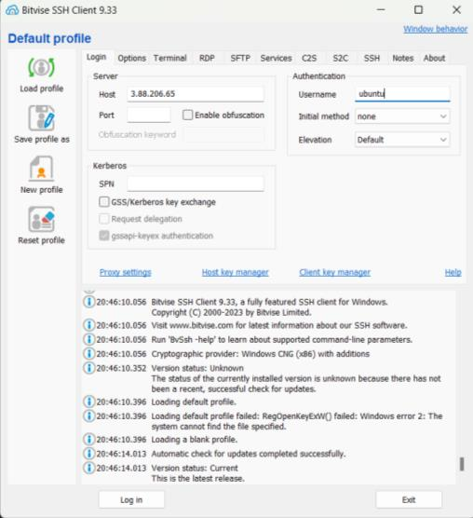

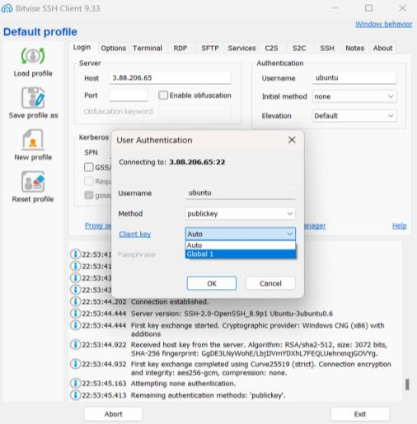

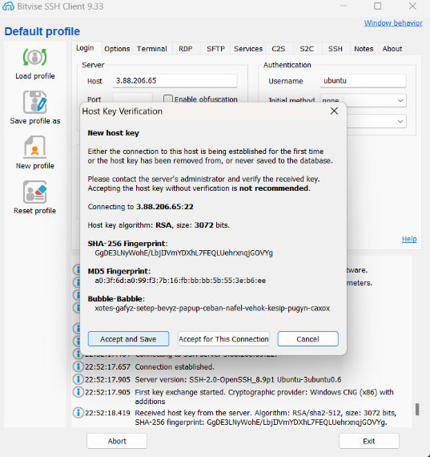

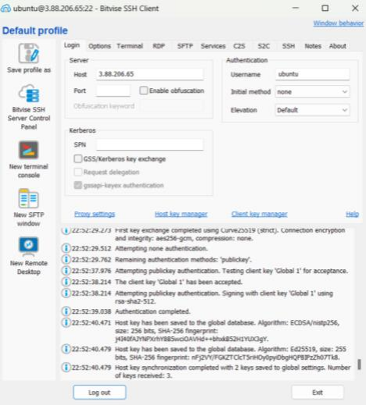

10. In ‘Bitvise SSH client’, under ‘Default profile’ click on ‘New terminal

console’ and there run ‘pwd’ command to check where we are.

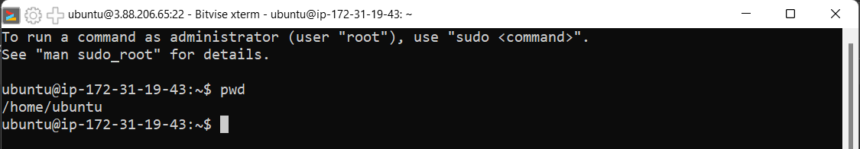

In terminal console, type the following commands.-> ‘sudo apt-get

update’ , ‘sudo apt-get upgrade’ , ‘sudo apt-get install nginx’.





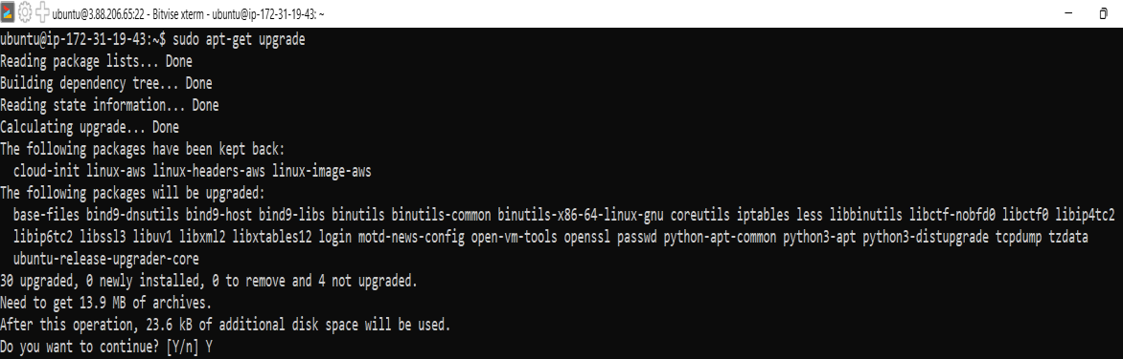



11.Check if www folder appears or not by using ‘ls’ command inside ‘var’

folder Now to give the file access permissions to it go back to the

‘www’ directory, and type the command ‘sudo chmod 777 html’ and

press ‘Enter’.

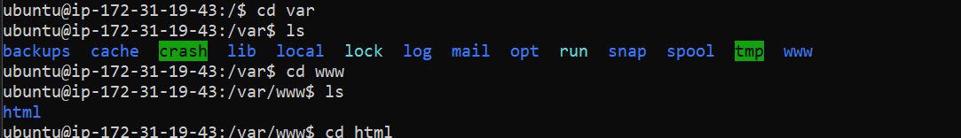

  


12. Now going back to the ‘SFTP Window’ under the ‘Remote Files’ open

the HTML directory and drag & drop the HTML files.

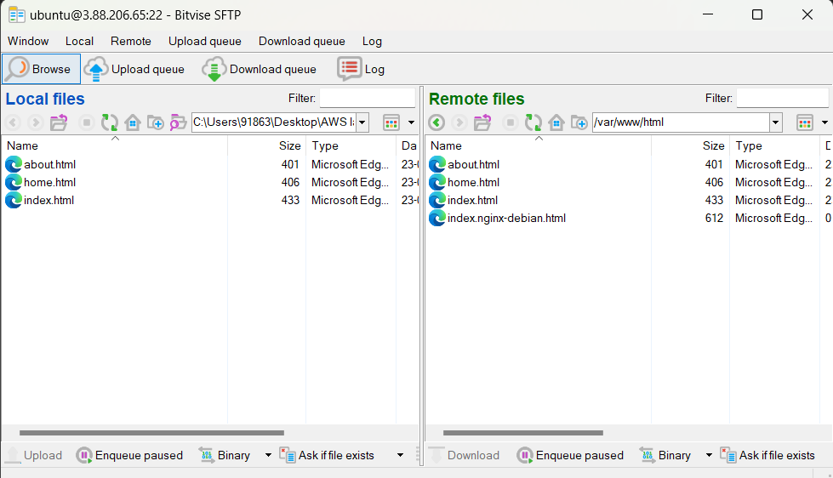

13. Now go back to the ‘AWS Window’ and copy the ‘IPV4 address’.14.

In a new window paste the ‘IPV4 address’.

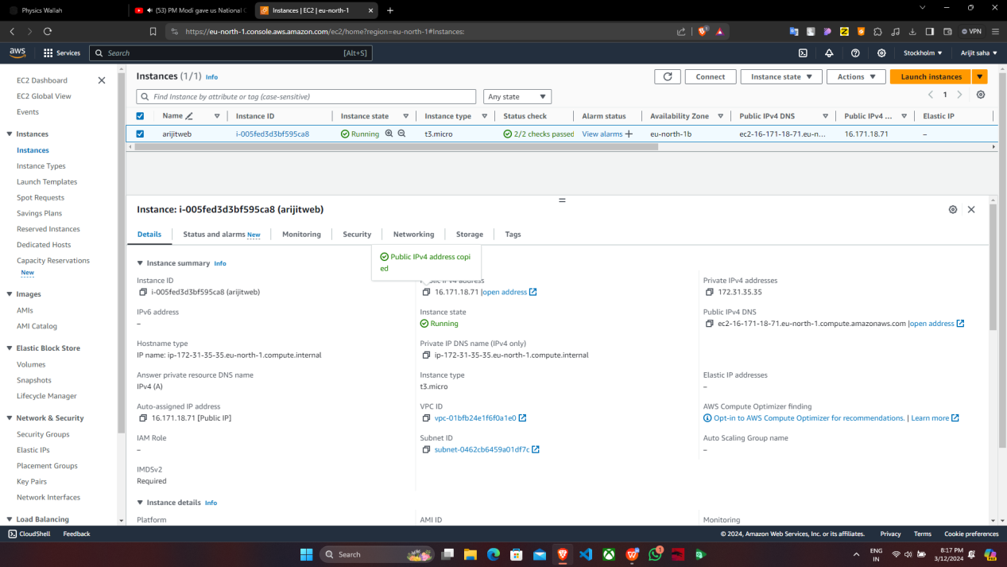

14. In a new window paste the ‘IPV4 address’

